**Assignment -4**

Python Programming

|  |  |
| --- | --- |
| Assignment Date | 28 October 2022 |
| Student Name | P.Rubak |
| Student Roll Number | 953719106036 |
| Maximum Marks | 2 Marks |

**Question-1:**

Download the dataset

**Output:**

Download the dataset from

<https://www.kaggle.com/code/kredy10/simple-lstm-for-text-classification/data>

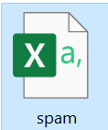

**Question-2:**

Import required library

**Output:**

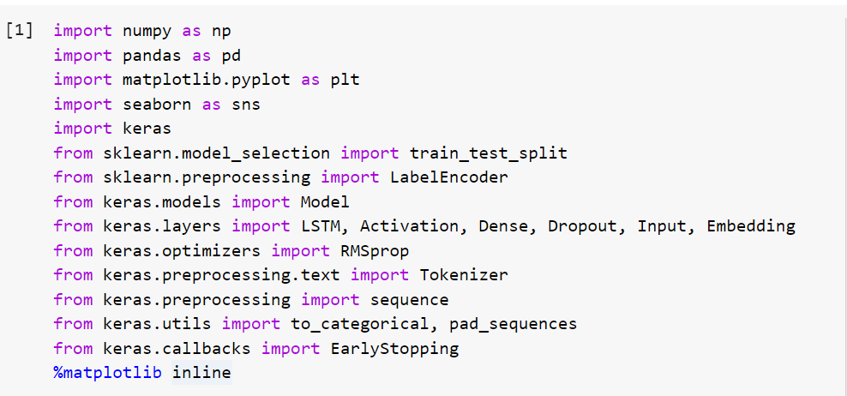

**Question 3:**

Read dataset and do pre-processing

**Output:**

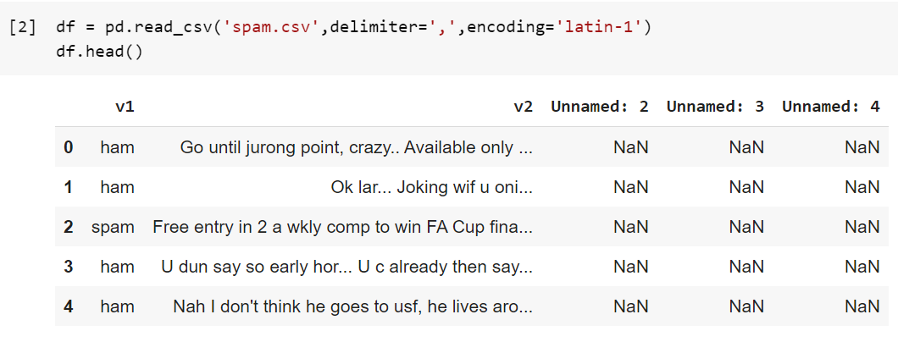

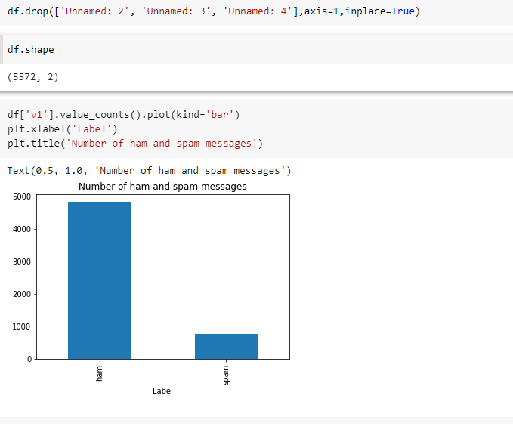

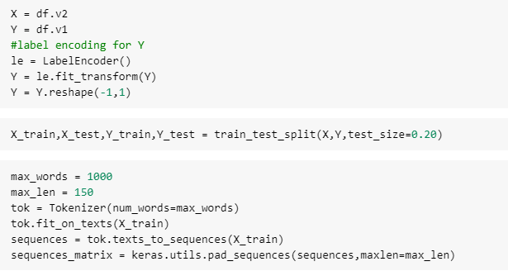

**Question 4:**

Create Model

**Output:**

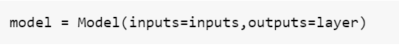

**Question 5:**

Add Layers (LSTM, Dense-(Hidden Layers), Output)

**Output:**

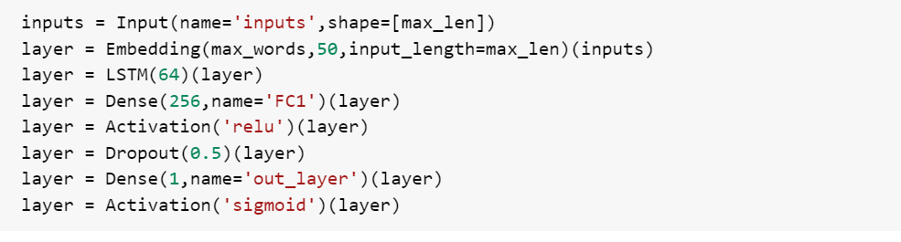

**Question 6:**

Compile the Model

**Output:**

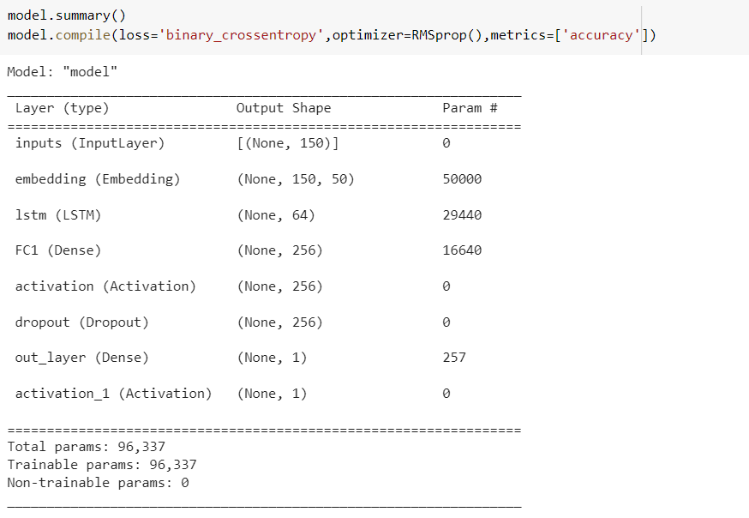

**Question 7:**

Fit the Model

**Output:**

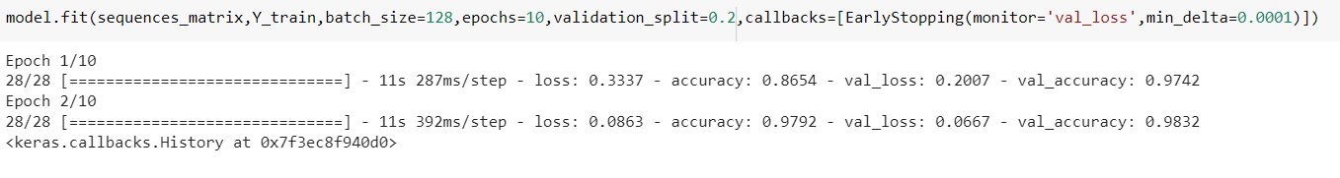

**Question 8:**

Save The Model

**Output:**



**Question 9:**

Test The Model

**Output:**

